PRESS RELEASE
Contact: Britney Britten, General Manager
Panhandle Groundwater Conservation District
(806) 883-2501
britney@pgcd.us

FOR IMMEDIATE RELEASE

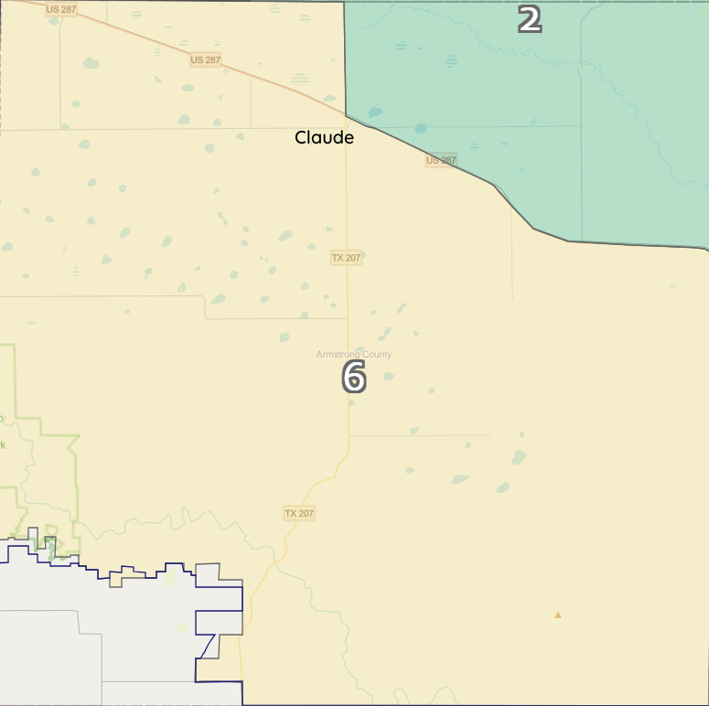
Panhandle Groundwater District to Hold Board Elections

WHITE DEER, TX. (April 17, 2023) – Panhandle Groundwater Conservation District Board of Directors elections are scheduled for Saturday, May 6, 2023. The four-year terms of four District Directors expire this year. These include: David Hodges- Precinct 2, Charles Bowers- Precinct 4, Jim Thompson- Precinct 6 and Danny Hardcastle- Precinct 8.

Two of the four Precincts only had one candidate sign up to be on the ballot. Per Texas Election Law, the election for those two precincts has been cancelled. Charles Bowers- Precinct 4 and Marcus Hardcastle- Precinct 8 will be duly elected in May.

Candidates running for Precinct 6, which covers most of Armstrong County, are Wes Stockett and Jimmy Osborn.

Go to www.pgcd.us/election-information to view an interactive map if you’re unsure which Precinct you reside, or call the District office at 806-883-2501.

